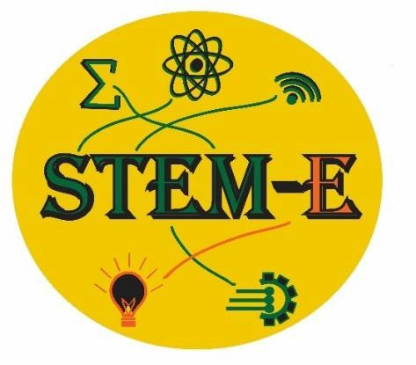

FALL STEM-E Conference Schedule

**2024**

**8:45 am - 9:30**: Schools Arrive & Check-In Gather in MS Auditorium (CAC)

**9:45 am – 11:00** am-Workshop I

**11:05 am**: **Lunch** meets at the *Gathering Place*

**11:30-*Transition to 2nd Workshop (ROTC)***

**11:45-12:45 pm-Workshop II 12:55pm - 1:00**: Dismiss Load Buses

*Cherokee High School JROTC Cadets will assist you in locating your rooms.

Please ***refrain*** from taking photos in the CCS hallways.

***STEM-E gratefully acknowledges the following organizations and dedicated volunteers who provide an***

***engaging learning experience for our students:***

* Cherokee Preservation Foundation for their vision and belief in the power of student engagement
* Duke Energy Foundation
* Harrah’s Scholarship Fund
* Smoky Mtn STEM Collaborative NASA
* Cherokee High School JROTC Cadets
* All presenters for designing and leading our workshops
* *A* **special Thank you** *to CCS Superintendent Consuela Girty, Dr. Beverly Payne, Carmen Davis, Technology Director, Debora Foerst, Joel Creasman, Paula Coker, Nathan Barker, Heath Robertson, Kenitra Corbin, Shawn Crowe, Carmen Davis, Daphne Driver, Brett Robertson, Dr. Emily Darling, Dr. Jan Webster, WRESA, Duke Energy Foundation, TELUS. All school district STEM-E Leaders whose organizational skills and technical knowledge made the conference happen!*

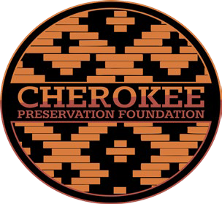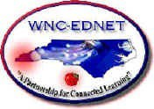

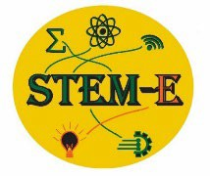***Welcome to the STEM-E FALL ES/MS Student Conference***

**Morning and Afternoon Session Locations -Friday, Sept 27-CCS Campus**

|  |
| --- |
| **Epoch of Bubbles:** [**https://astro3d.org.au/education-and-outreach/epoch-of-bubbles-**](https://astro3d.org.au/education-and-outreach/epoch-of-bubbles-activity/)[**activity/**](https://astro3d.org.au/education-and-outreach/epoch-of-bubbles-activity/)This activity is aiming to replicate the bubble-like structures that formed during the epoch of deionization. The bubble solution represents the neutral hydrogen, and the air inside the bubbles is transparent ionized hydrogen.  About 380,000 years after Big Bang, the Universe had cooled and expanded enough that there were vast quantities of hydrogen (and a bit of helium) everywhere and not much else. This neutral hydrogen (a proton and an electron) created an opaque “fog” that light could not penetrate, called the Cosmic Dark Ages, and most of the Universe is unobservable. Any electromagnetic radiation that might have been emitted was quickly absorbed by the hydrogen gas. As the hydrogen atoms slowly collapsed into more dense regions due to gravity, forming the first stars, the light emitted from them tore the electrons off the hydrogen atoms, creating transparent regions around them, like bubbles.  **Dr. Christine Lynch**  **UNC-Asheville** Department of Physics & Astronomy University Fellow  Email /contact: [clynch2@unca.edu](mailto:clynch2@unca.edu) |
| **Zaniac-Scratch Lab Face Sensing**  Experience Machine Learning using Scratch Lab Face Sensing. The Scratch Lab  website <https://lab.scratch.mit.edu/> lets you explore an unreleased Scratch Add-On the MIT Scratch team are developing right now. Using this tool you can build code for new games using the camera on your computer and a face for a more interactive experience.  **Christi Whitworth Senior Instructor**  **Zaniac Learning, Asheville, NC**  [**christi.whitworth@zaniaclearning.com**](mailto:christi.whitworth@zaniaclearning.com) |
| **“Powered by the Sun”**  How are solar panels made? How do they work? What are the building blocks of solar PV system design? In this session you’ll learn the basics of how the sun’s energy is harnessed to power homes and buildings. Get your hands on a solar panel and, weather permitting, put it to work to see the affect shade, tilt and orientation have on the panel’s power production. You’ll then analyze the annual energy usage for an average school and use this information to help our designer create a simple solar PV design for the Cherokee Central Schools campus.    Rebecca Morris  **Director of Marketing**  **53 Asheland Avenue, Ste 103, Asheville NC 28801**  **O: 828.615.6056 x3 C: 828.215.8738**  [**pisgahenergy.com**](https://www.pisgahenergy.com/) |

|  |
| --- |
| **Food For Thought STEM Challenge Kit**  Food for Thought is a collection of three engaging activities that equip kids with fundamental knowledge of factors that contribute to Food Security, how people are impacted both globally and locally, and how youth can personally contribute to creating a more food secure community.  Leah Jorgensen  4-H Youth Development Haywood County Center NC Cooperative Extension |
| **Atsila Anotasgi (Fire Builders), *Museum of the Cherokee Indians, Cultural Specialists***  *Rotate through 2 stations to learn more about Cherokee Culture and Games*  **Location: Outdoor Session – School Track-Rain-Multi Purpose Room** |
| **A Walk in Nature with National Park Service-Journaling**  **Mindful nature walks with reflection time. Draw or write your responses to a few prompts, or reflect on your own about your surroundings, science, and nature.**  **Presented By: Kaylyn Barnes**  Education Park Ranger - NC  Great Smoky Mountains National Park-Office: 828-497-1907 Cell: 414-587-1503 |
| **STEM-E GEM** |
| Plaque Attack and Health Care Heros! Meet Children Book Arthur, Kristina Hyatt, who will share about health care fields. Explore experiments that demonstrate a plaque attack and how different beverages affect your teeth. Plaque is a fancy name for the fuzzy ﬁlm on your teeth, that you’ll especially notice if you haven’t brushed in a few days. Also learn about the MedCat Program that is available to support students interested in pursuing medical careers.  Presented by:  Kristina Hyatt, RDH – Center for Native Health, Program Officer – Maternal & Child Health  [kristinalhyatt@gmail.com](mailto:kristinalhyatt@gmail.com)  Madison Leatherwood – Center for Native Health, Program Officer – Education & Training |
| **World of 3-D Design**  In this hands-on workshop, you’ll dive into the world of 3D design by creating your very own game piece. You’ll start by designing your piece using 3D modeling software, with the option to bring your laptop or use one of the provided workstations. Once your design is ready, you'll see how it translates into a physical object through 3D printing. By the end of the session, you’ll leave with your digital you'll see how it translates into a physical object through 3D printing. By the end of the session, you’ll leave with your digital custom-designed game piece and a pre-printed game piece version to take home, showcasing both the creative and technical sides of the design process.  Scott Freeman  Cherokee High School  CTE teacher Drone and Computer Programming  [scott.freeman@ccs-nc.org](mailto:scott.freeman@ccs-nc.org)  828-506-6992 ex 23212 |